E/15/385

Weerasinghe S.P.A.P.E

CO322 Data Structures and Algorithms - 2019

**Lab 4 - Tree ADT**

**Radix Tree (Trie) Structure for Text Auto-complete**

**Part 1:**

**Design was done successfully.**

**Following is the structure of the node**

typedef struct trienode{

struct trienode *child [26];//pointers to maximum should hold 26 char (alphabet)

bool isEnd;//to mark if the node is a leaf

}TrieNode;

Each node in the trie is associated with a letter in the alphabet. So one of the node should be associated with maximum of 26 edges, where each node associated with letter from the alphabet

Following is an example how I am gonna insert words

to,ted,tea,ten,inn,A, and inn

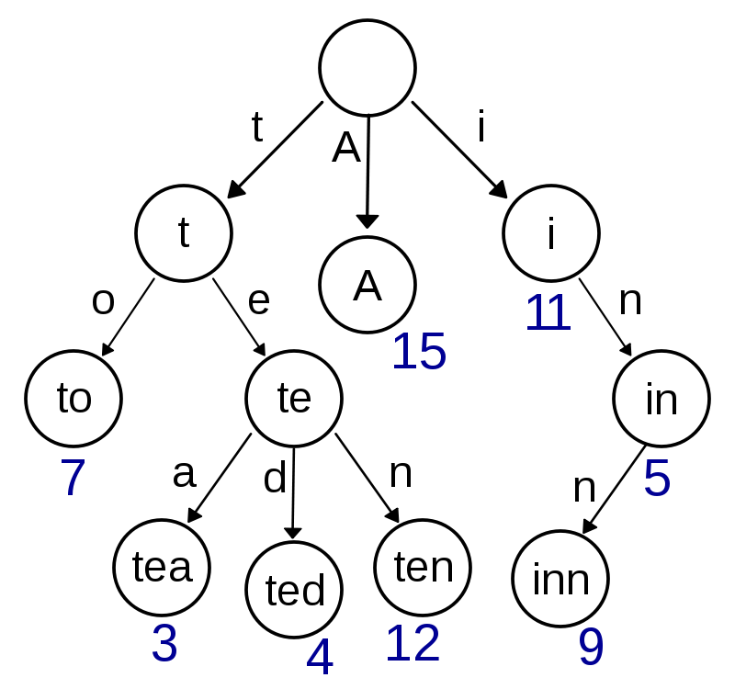

* Root is empty
* Let’s insert “to”

Steps

1.Go to root

2.Check weather there is an edge associated with “t”

3.if there is no edge associated with “t” , create a new node

4.make the “childIndex” associated with letter “t”

5. Then we have to insert letter “o”

6.go to node.

7.Check weather there is an edge associated with “t”

8.We have an edge then go to the node associated with ‘t’

9.check weather there is an edge associated with “o”

10.if not create a new node associated with “o”.

11.mark it as isEnd=”true”, because the word want to insert is over

12. repeat the above process for other words(ted ,tea,ten,A,inn)

13.For ‘ted ’ we already have edge associated with “t”

14.Therefoe we have to create “e” and “d ” from “t”.

15. continue the process like this

How Autocomplete is designed

1.user input word is taken

2.start from the root node

3.search thorugh the trie until the user input is completely found

4. then assign the ending point as the new root.

5.call the “printsuggestions” function

6.Print all possibilities till all leafs prefixed with what user inputs

How to calculate the memory usage

1.Here first i need to find the Size of the Structure created for a node

2. line 130 of my code

printf("Size of struct: %ld", sizeof(struct trienode));

using this I find the size of a single node I am creating.

Size of struct: 216

3.Now I have to create aa global counter variable for number of nodes and multiply it with size of a node

Part 02.